Dashboard Headings & Visual Details
- KPI Cards (Top Metrics)
  - Total Employees
  - High Stress %
  - Average Working Hours
  - Average Work-Life Balance
  - Overworked Employees
  - Physically Active
  - Average Age
  - Average Social Isolation
  - Average Stress Score
Use as a KPI summary section.
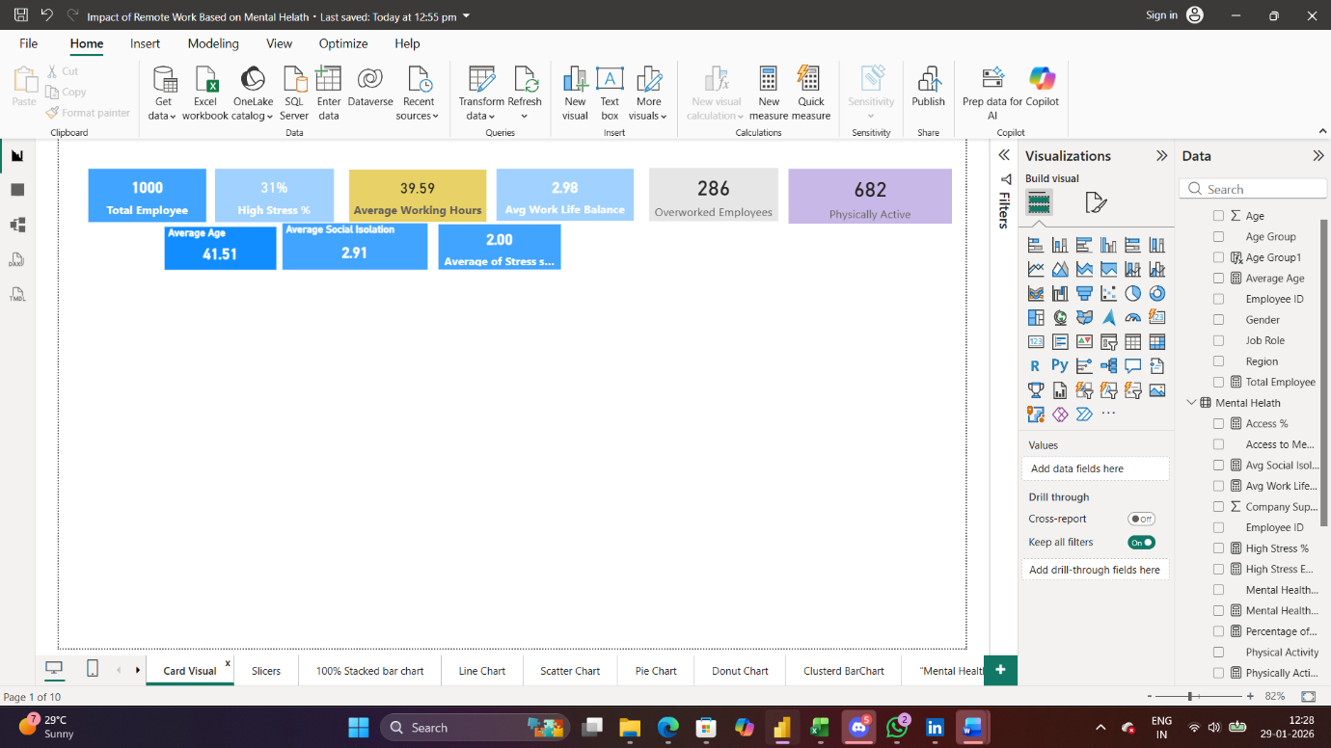

Slicers / Filters
- Gender
- Age Group
- Job Role
- Work Location
Interactive filters for all charts.
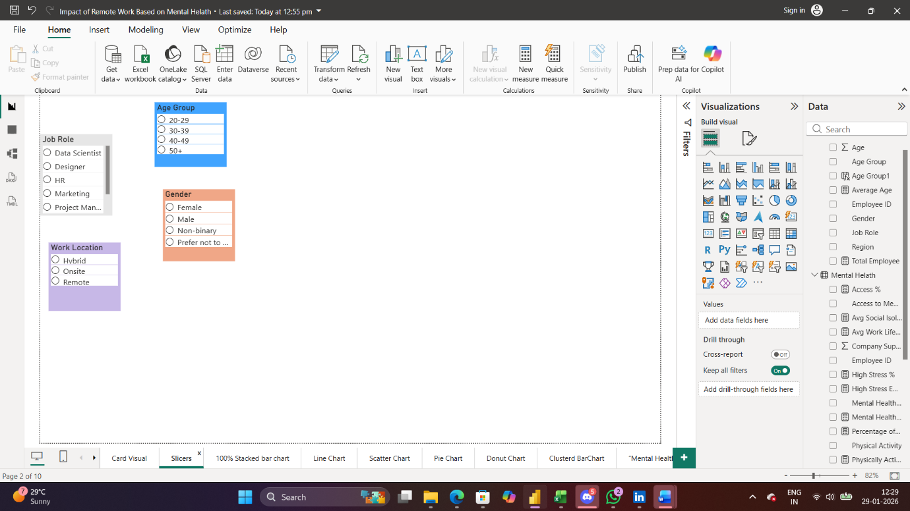

Line Chart
- Title: Stress Trend by Age
- Purpose: Show how average stress scores vary across different age groups over time or categories.
• 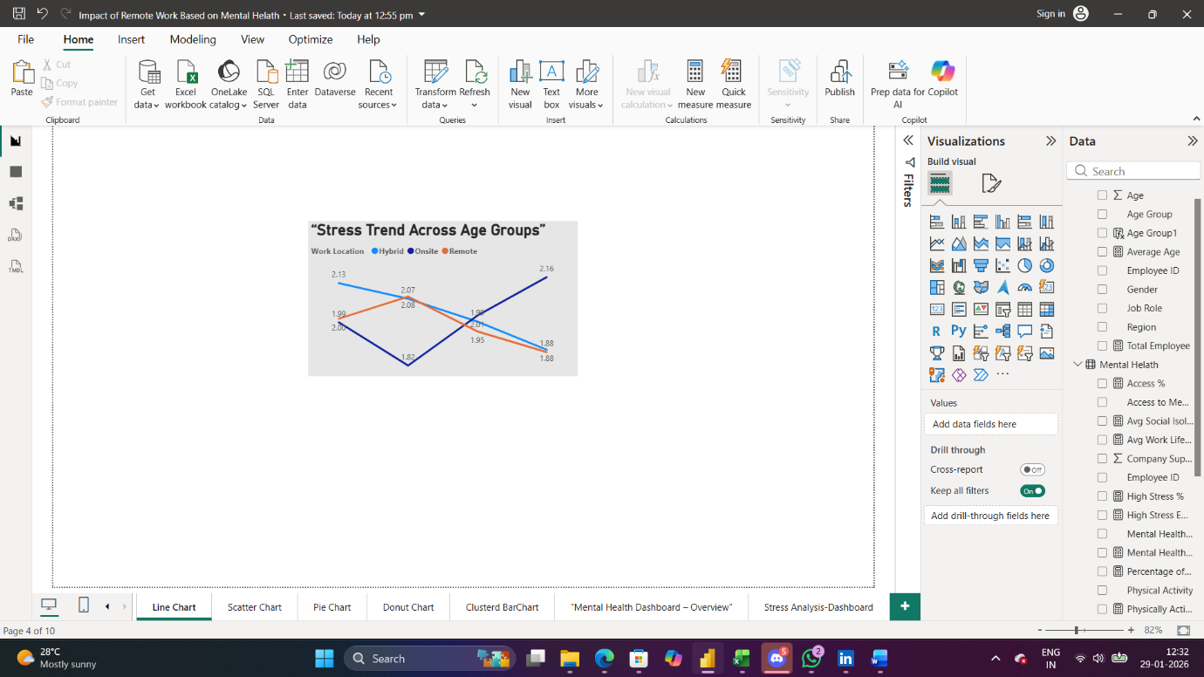

100% Stacked Bar Chart
- Title: Mental Health by Work Location
- Purpose: Compare mental health conditions (Anxiety / Burnout / Depression / None) across Remote, Hybrid, and Onsite employees.
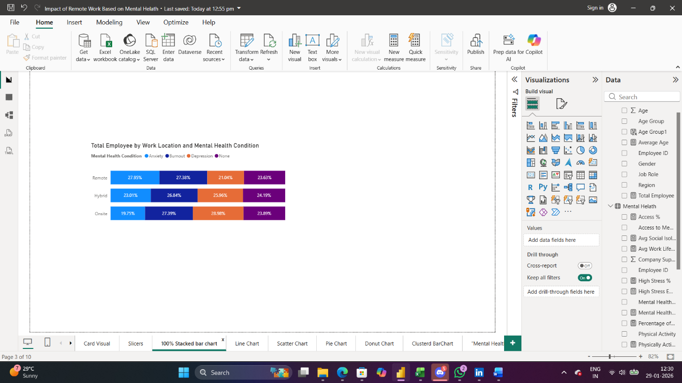

Scatter Plot
- Title: Working Hours vs Stress
- Purpose: Analyze relationship between weekly working hours (or overtime) and stress score.
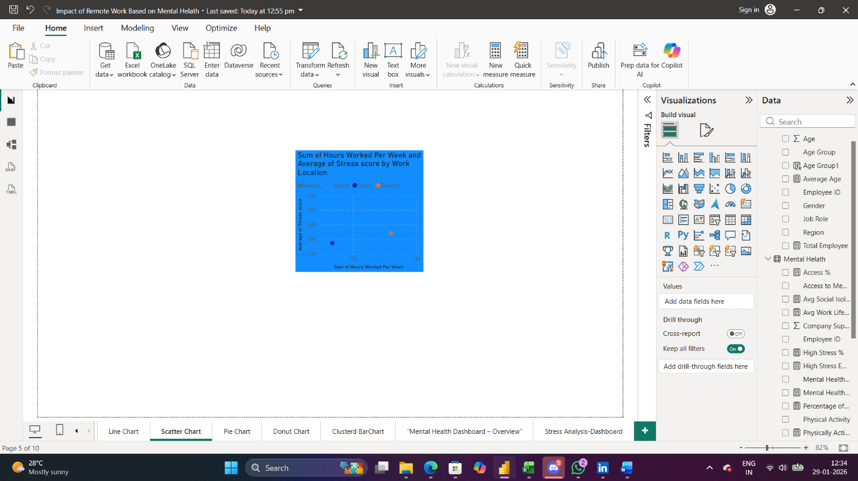

Bar Chart
- Title: High Stress % by Job Role
- Purpose: Identify which job roles have the highest proportion of employees under high stress.
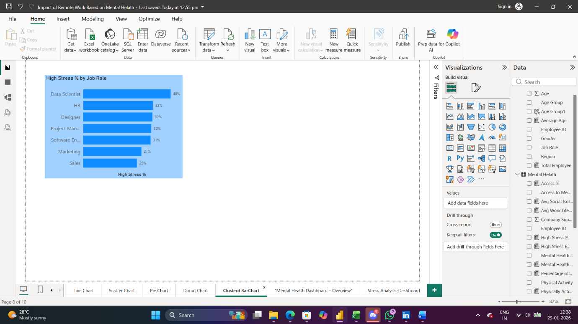

Pie Chart
- Title: Experience Level Distribution
- Purpose: Visualize distribution of Junior / Mid / Senior / Expert employees.
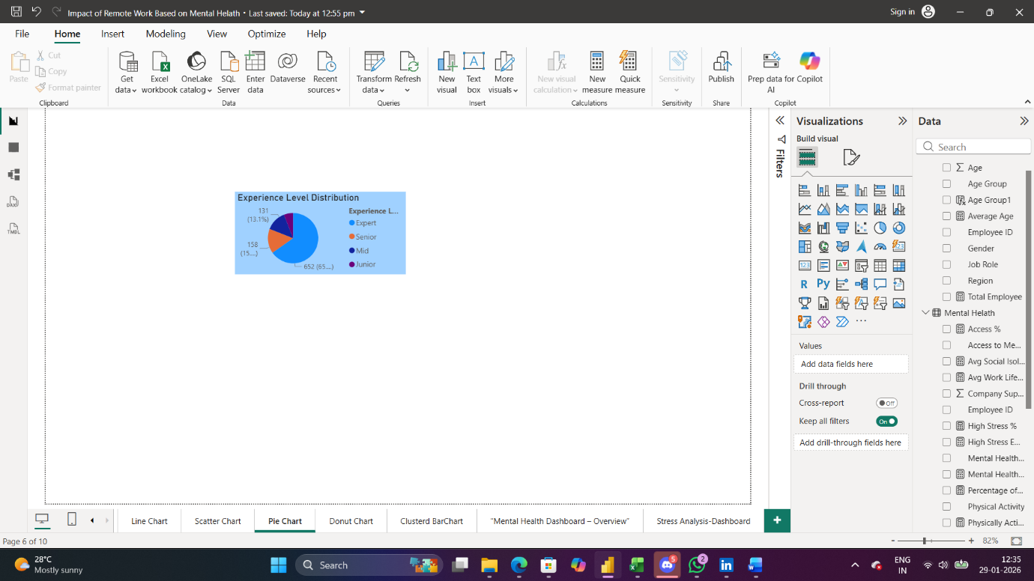

Donut Chart
- Title: Stress Distribution
- Purpose: Show proportion of Low / Medium / High stress levels across all employees.
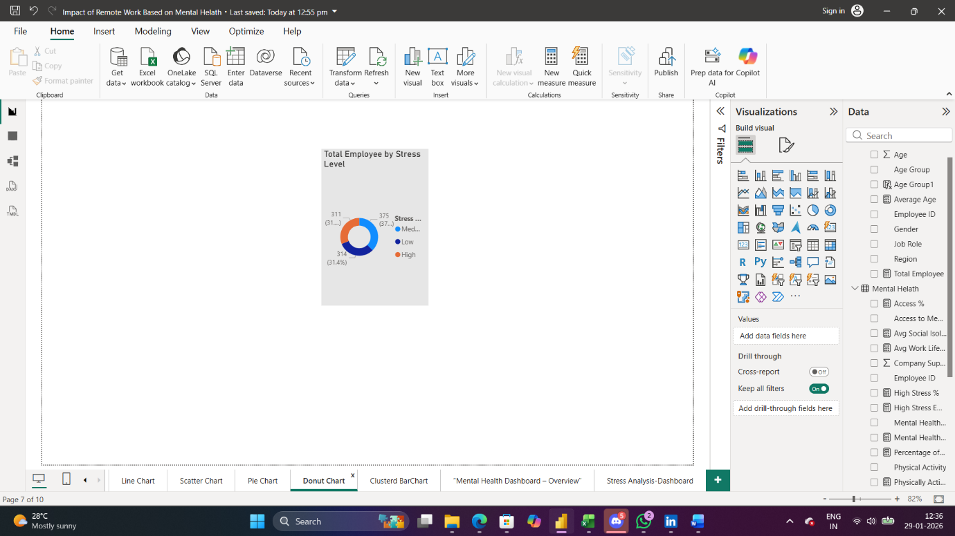

Mental Helath Overview Dash Board
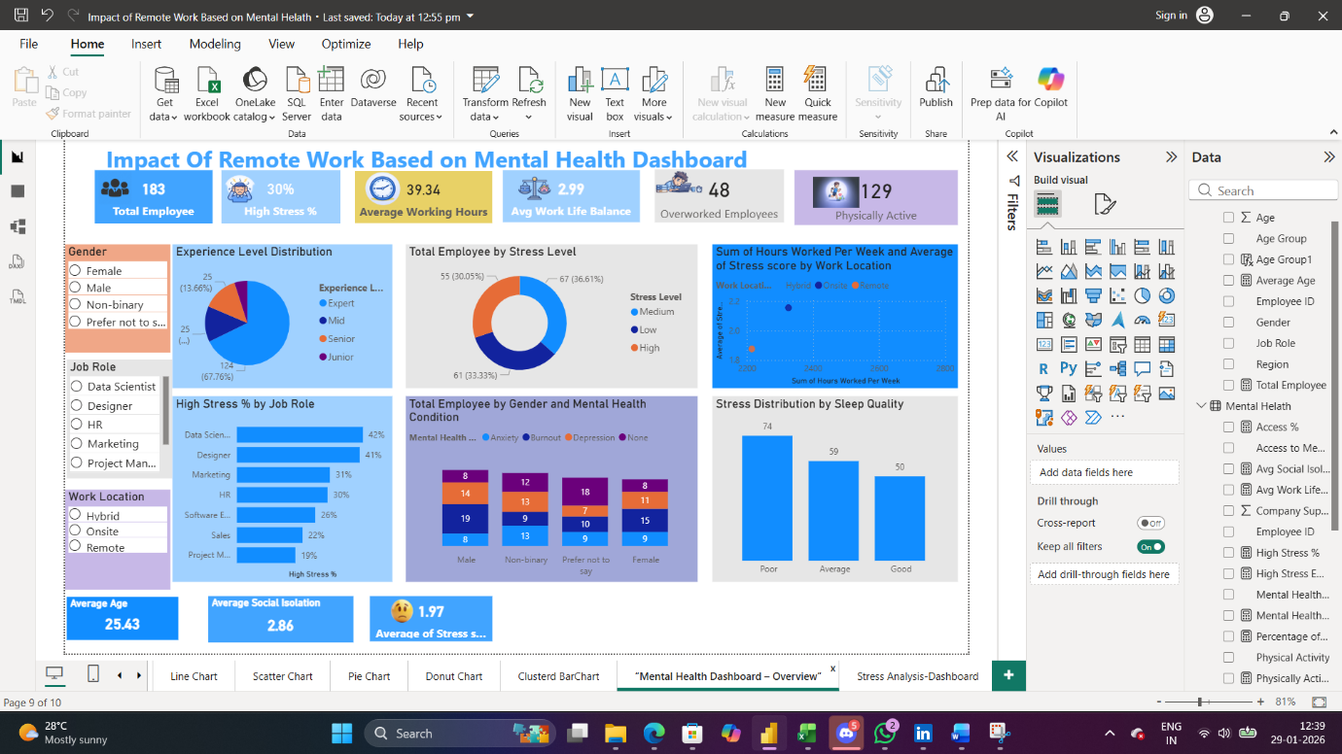

Strees Analysis DashBoard